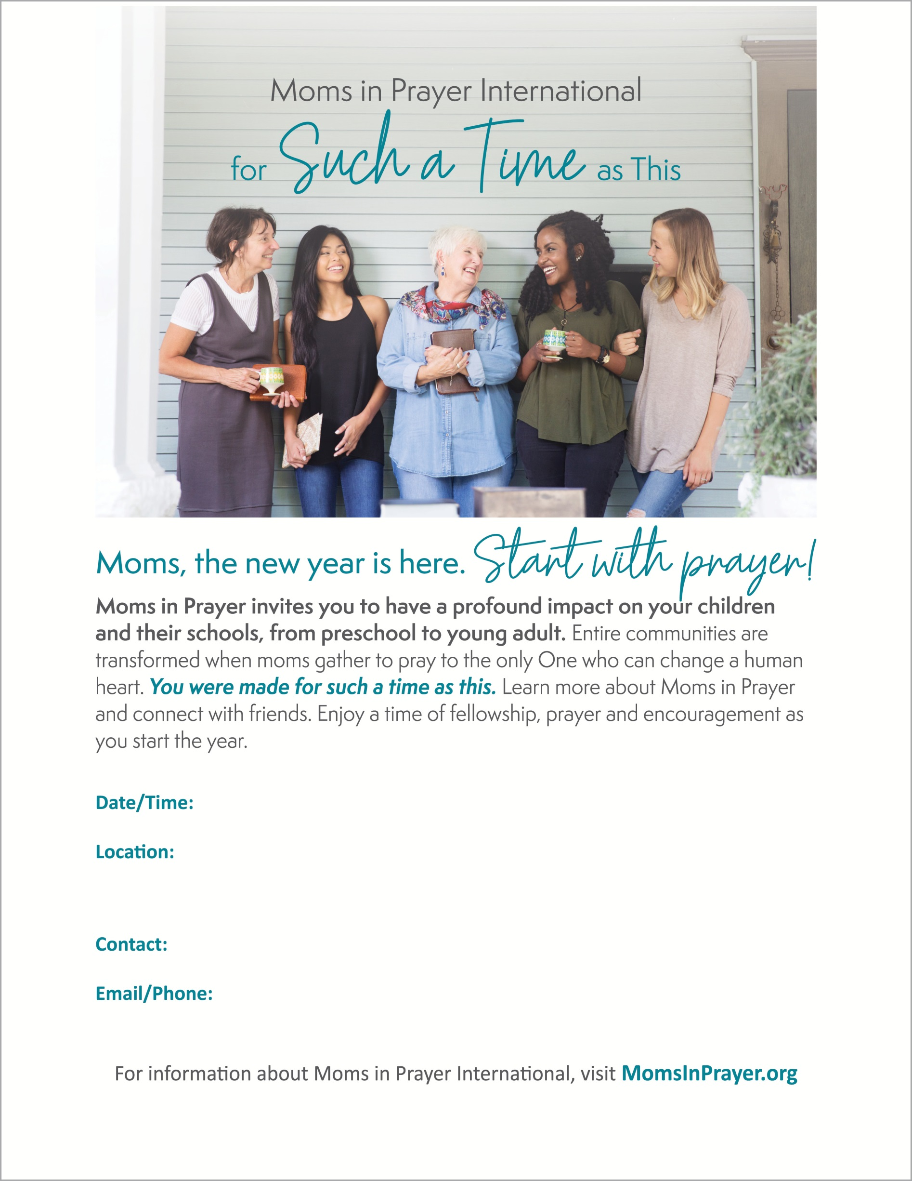

**Type phone/email here**

**Type street address here**

**Type name of location (church name, home of, etc.) here**

**Type name of contact and optional title here**

**Type event date and time here**