
Praise—praising God for who He is, His attributes, His name or His character
Attribute: God is Sovereign/El Elyon, The God Most High
Definition: One who is above or superior to all others, controls everything, can do anything
Scripture(s): Isaiah 46:9-10; 2 Samuel 7:22; Psalm 71:5; Jeremiah 32:17
Confession—silently confessing your sins to the God who forgives
If we confess our sins, He is faithful and righteous to forgive us our sins and to cleanse us from all unrighteousness. 1 John 1:9 (NASB)
Thanksgiving—thanking God for what He has done
In everything give thanks; for this is God’s will for you in Christ Jesus. 1 Thessalonians 5:18 (NASB)
Intercession—coming to God in prayer on behalf of others
Our Own Children—each mom chooses one child
Scripture: Sovereign LORD, help ________ for Your name’s sake; out of the goodness of Your love,
deliver ________. From Psalm 109:21
1st Mom’s Child specific request:
2nd Mom’s Child specific request:

3rd Mom’s Child specific request:
Teachers/Staff
Scriptures: Use the verse below or the verse for your child.
Open __________’s eyes and turn him/her from darkness to light, and from the power of Satan to God, so that he/she may receive forgiveness of sins and a place among those who are sanctified by faith in Jesus.
From Acts 26:18 (NIV)
School Concerns
- May there be revival and spiritual awakening on each campus.
- May administrators have continued wisdom as they make daily decisions.
- May there be good communication between teachers and students as they adapt to online learning.
- Draw school staff and students to online church services this Easter Sunday.
- Allow schools to continue to provide no cost lunch distributions for those in need.
- Draw staff and students that struggle with anxiety to You Lord and give them peace.
- Meet the financial needs of bus drivers, support staff, coaches, and all campus employees who
are not working.
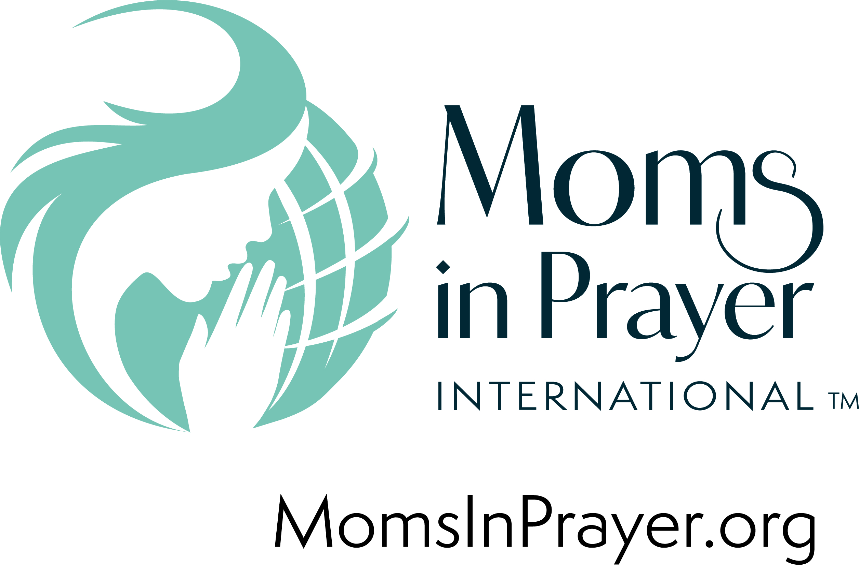
Moms in Prayer Concerns—Every school worldwide covered in prayer, protect the ministry keeping it pure and unified, that many will donate to impact more children and schools for Christ.
Remember, what is prayed in the group, stays in the group!

