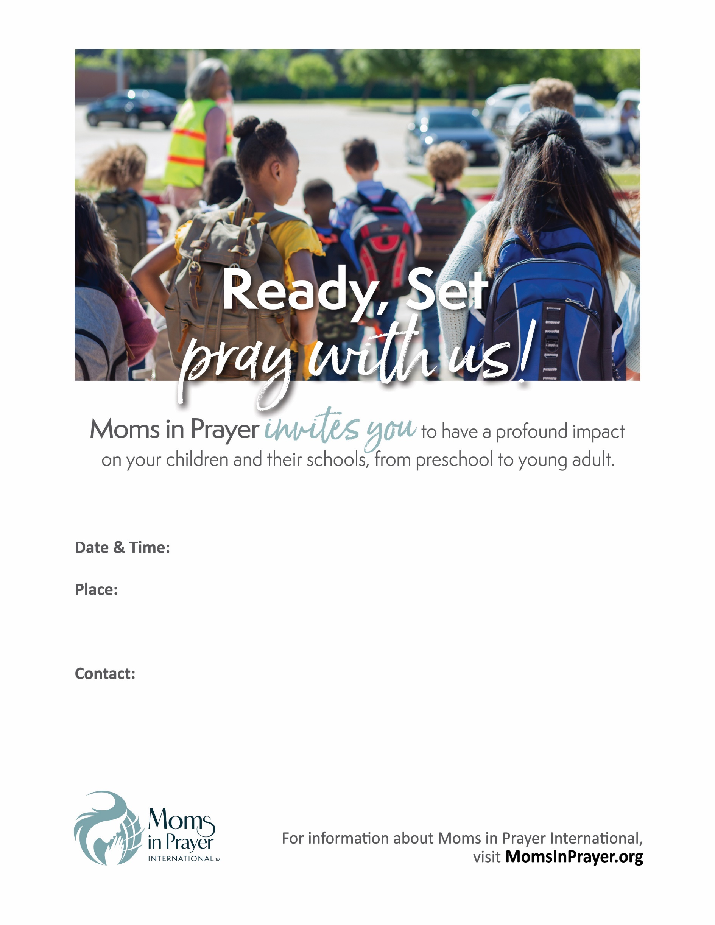

**Coffee, tea, and dessert will be served after our program.**

**Childcare is not provided.**

**Name of Contact, Phone, email@gmail.com**

**12345 Name of Street, City, State Zip**

**Name of Church or Home of Your Name Goes Here**

**Saturday, September 00, 2020 from 10 to 11:30 am**

**Your Event Title Goes Here**