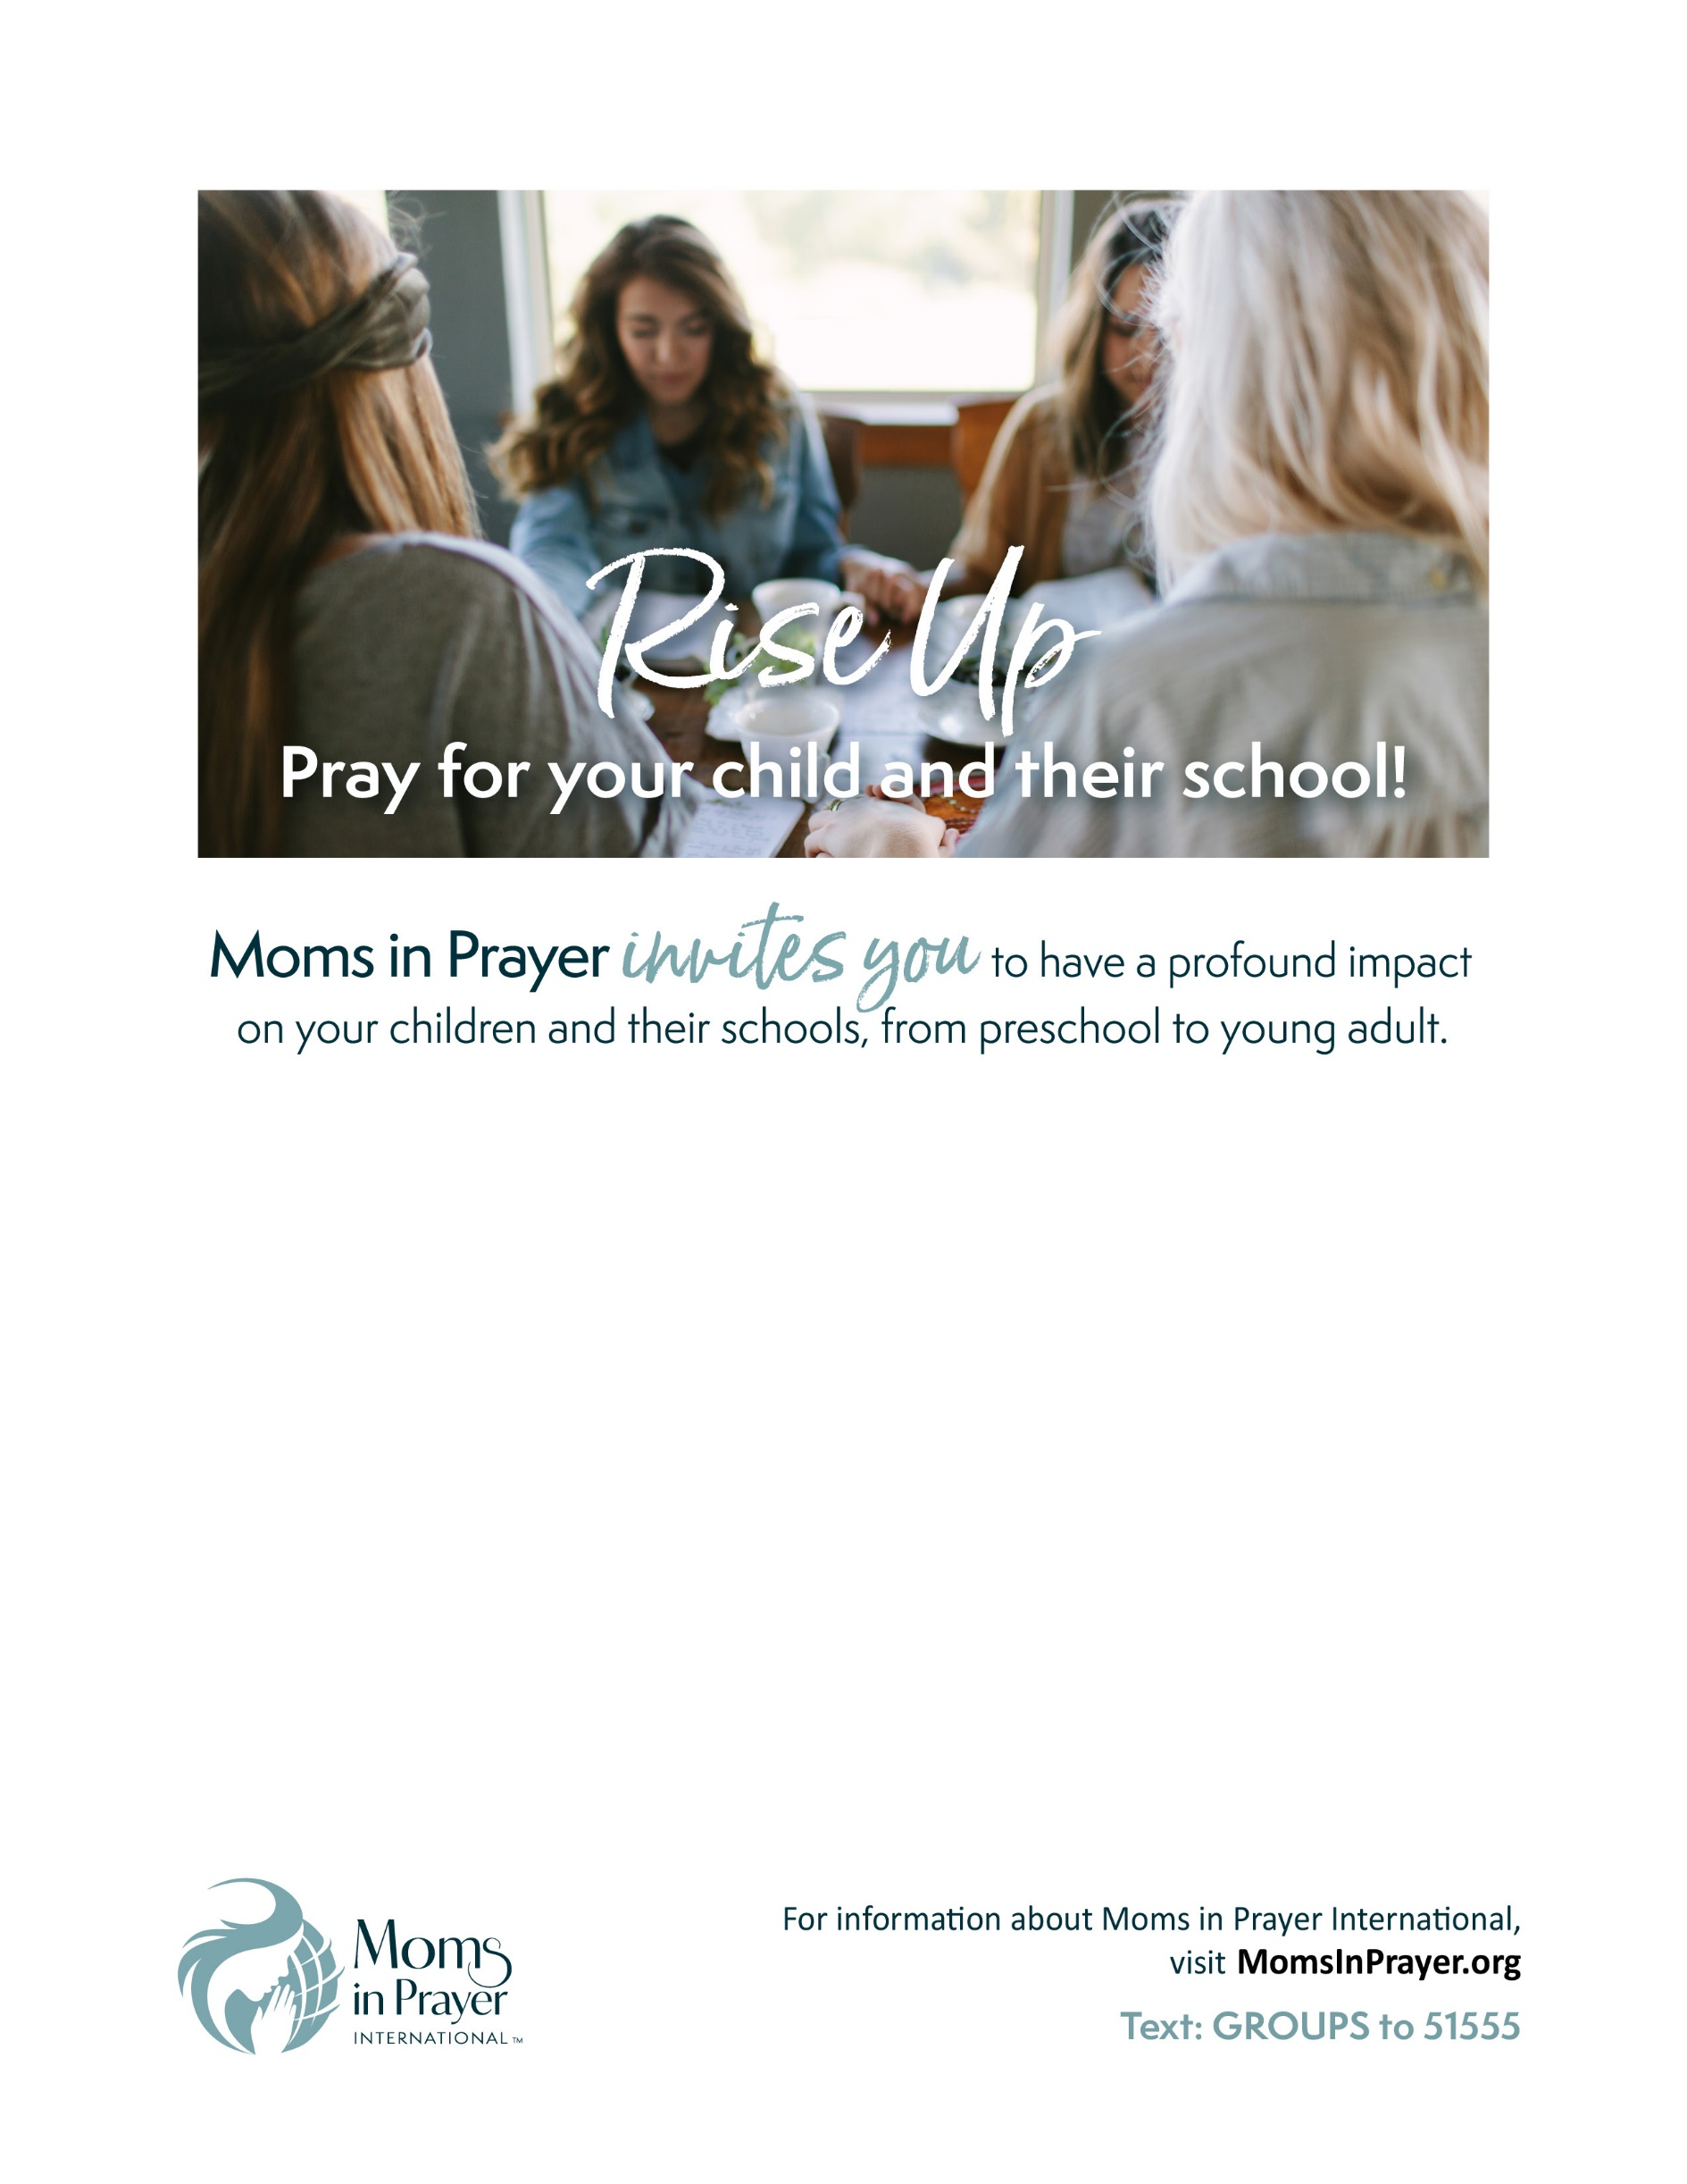

**Type Your Event Title Here**

Type & Date Time Saturday, September 00, 2020

10 to 11:30 am

Type some text about what’s happening at this event, where it is, city and church, who the speakers are and other information. Some text about what’s happening at this event, who the speakers are and other information.

Type other information Connect with friends, enjoy a time of fellowship, prayer and encouragement. Light refreshments, no childcare provided, etc.

Type Contact person and her email address and phone