Praise—Praising God for who He is, His attributes, His name or His character
Attribute: Jesus is the Way, the Truth and the Life
Definition: Faith in Jesus Christ is the only way of salvation for sinful human beings.
Scriptures: John 14:6, Deuteronomy 30:19-20, Isaiah 35:8, John 6:63, Acts 4:12, 1 Timothy 2:5, Hebrews 10:20, 1 John 5:20

Thoughts: Jesus didn’t say that He would show us a way; He said that He is the way. He didn’t promise to teach us a truth; He said that He is the truth. Jesus didn’t offer us the secrets to life; He said that He is the life. (Guzik)

Confession—Silently confessing your sins to the God who forgives
If we confess our sins, He is faithful and righteous to forgive us our sins and to cleanse us from all unrighteousness. 1 John 1:9 (NASB)
Thanksgiving—Thanking God for what He has done
In everything give thanks; for this is God’s will for you in Christ Jesus. 1 Thessalonians 5:18 (NASB)
Intercession—Coming to God in prayer on behalf of others
Our Own Children—Each mom chooses one child. First pray the scripture then pray a specific request.
Scripture: Jesus, You are the Way, the Truth and the Life. May ________ (child’s name) choose life that he/she may truly live. From John 14:6, Deuteronomy 30:19-20a (NASB)
(NASB)
1st Mom’s Child specific request:

2nd Mom’s Child specific request:

3rd Mom’s Child specific request:
Teachers/Staff—Use the verse below or the verse for your child.
Scripture: Open __________’s eyes and turn him/her from darkness to light and from the power of Satan to God, so that he/she may receive forgiveness of sins and a place among those who are sanctified by faith in Jesus. From Acts 26:18
School Concerns
- Pray for revival and spiritual awakening at your school.
- Pray for protection over the staff and students at your school.
- Pray for other concerns at your school.
Moms in Prayer Concerns
- Pray that every school worldwide would be covered in prayer and that groups will be sustained.
- Pray for protection over the ministry, keeping it pure and unified.
- Pray for more donors to partner with the ministry in equipping groups and reaching the nations.
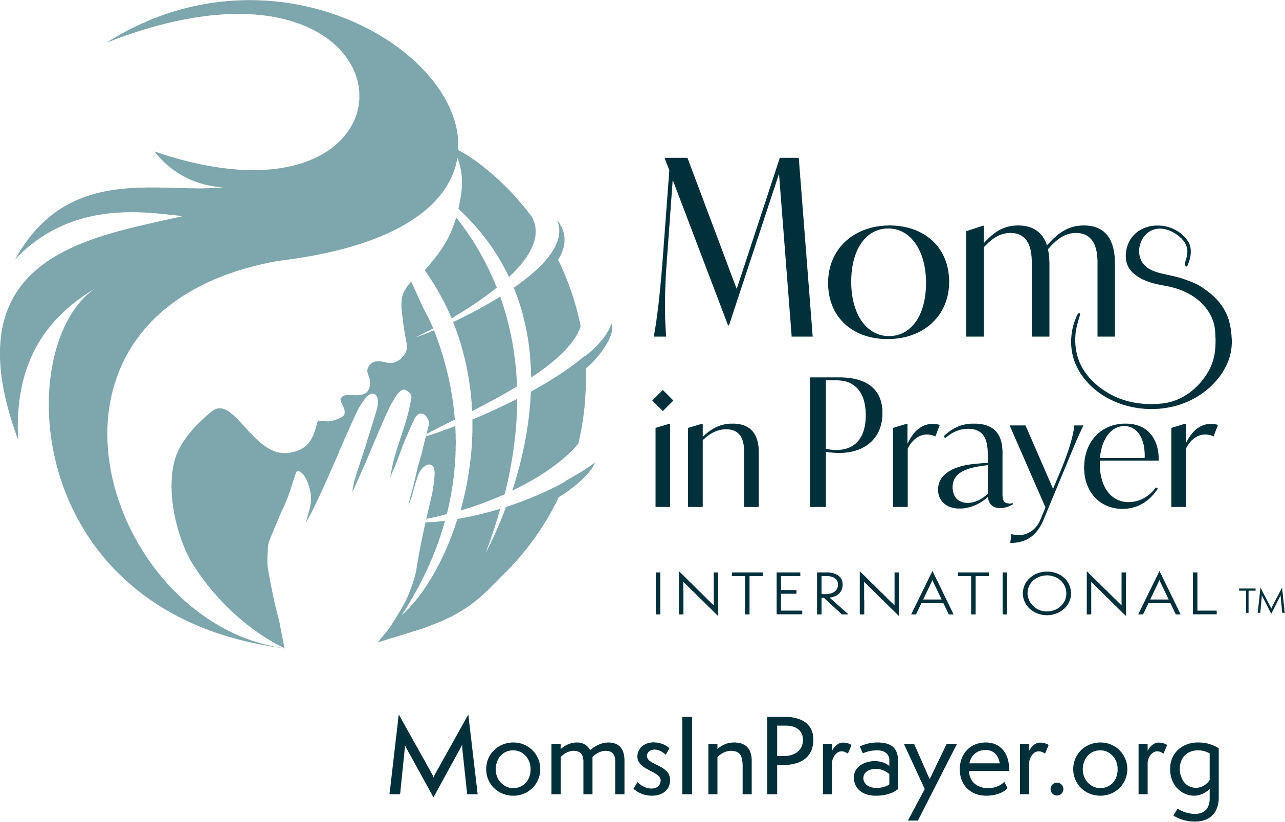

Remember, what is prayed in the group, stays in the group!
Jesus is the Way, the Truth and the Life

Praise scriptures (NLT):

Jesus told him, "I am the way, the truth, and the life. No one can come to the Father except through me.” John 14:6

Today I have given you the choice between life and death, between blessings and curses. Now I call on heaven and earth to witness the choice you make. Oh, that you would choose life, so that you and your descendants might live! You can make this choice by loving the LORD your God, obeying him, and committing yourself firmly to him. This is the key to your life. Deuteronomy 30:19-20a

And a great road will go through that once deserted land. It will be named the Highway of Holiness. Evil-minded people will never travel on it. It will be only for those who walk in God’s ways; fools will never walk there. Isaiah 35:8

The Spirit alone gives eternal life. Human effort accomplishes nothing. And the very words I have spoken to you are spirit and life. John 6:63

There is salvation in no one else! God has given no other name under heaven by which we must be saved.
Acts 4:12

For there is one God and one Mediator who can reconcile God and humanity--the man Christ Jesus.
1 Timothy 2:5

By his death, Jesus opened a new and life-giving way through the curtain into the Most Holy Place.
Hebrews 10:20

And we know that the Son of God has come, and he has given us understanding so that we can know the true God. And now we live in fellowship with the true God because we live in fellowship with his Son, Jesus Christ. He is the only true God, and he is eternal life. 1 John 5:20

Impact your children’s lives & local schools through prayer!
Join a Moms in Prayer Group at MomsInPrayer.org

