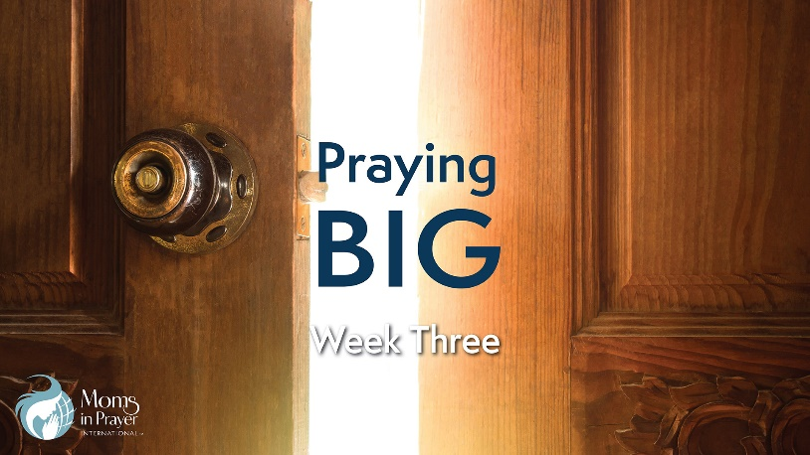
Petitioning the King
Intercession
With Susan Shepherd, USA Country Coordinator of Moms in Prayer International

To view the accompanying video, go to MomsinPrayer.org/bible-study

Group Discussion Question: What holds you back from praying for the great big, out-of-reach things?

- Read Romans 8:26-27 and Hebrews 7:23-27.

How much help has been promised to us as we pray?

Why is this help possible? When is it available?

Do our prayers need to be perfectly voiced? Why or why not? How does this encourage you to pray BIG?

- Read Mark 9:14-29

How does belief impact our prayers?

How does the father of the young boy respond? In what ways are you like this father?

How can you prepare your heart, mind, and soul to pray bigger prayers in faith?

- Read Genesis 18. Pay particular attention to verses 20-33. This is the account of Abraham interceding on behalf of Sodom where his nephew Lot lived.

Record your observations from the passage. What happened?

Who was present? What was the outcome?

How does this inspire you to intercede for anyone or anything you may have felt was a lost cause?
- What is a need that seems impossible today? What is heaviest on your heart? Take this to your Father right now, and give it to Him. Pray Big.

Write out your prayer and date it. Keep praying this prayer until you’re able to record His sweet answer.

This resource is made available for individual use. No part of this study may be copied or distributed in conjunction with any another work or compilation. It may not be posted to any other website. All verses are NIV unless otherwise noted. For more information on Moms in Prayer International, visit MomsInPrayer.org.

