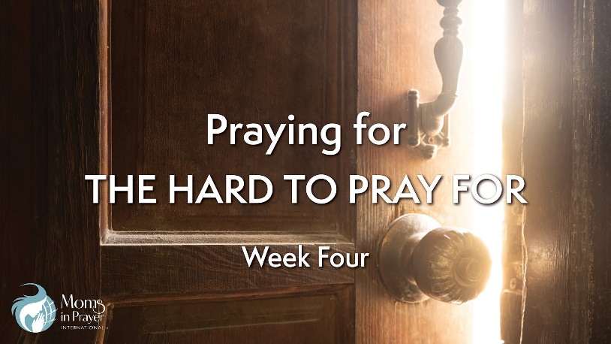

Petitioning the King
Intercession
With Susan Shepherd, USA Country Coordinator of Moms in Prayer International

To view video, go to MomsInPrayer.org/bible-study

Group Discussion Question: Why do you think some situations or people are hard to pray for?

- Read the following Scriptures. What do these verses tell us about how God works in us as we pray and serve Him? How have you experienced Him working in your life? Have you seen Him work in the lives of your children in these ways?

Philippians 2:13

John 17:17

1 Thessalonians 2:13

2 Thessalonians 2:13

Hebrews 13:20-21

- When a situation or person leaves you stunned, almost breathless and confused, praying God’s attributes, His character, and His Words can bring comfort, hope, and help.

How do the verses below impact you? What did you learn?

Have you used them as a prayer? What was the result?

I encourage you to memorize one, or all of them, so that you may use the Sword of the Spirit at any moment and be a weapon for righteousness.

Isaiah 41:9b-10

Isaiah 43:2-3a

Romans 5:3-5

Psalm 46:1-3, 10-11

Psalm 91:1-2, 14-16

Romans 8:28, 37-39

- Romans 12:1-2 encourages and instructs us to offer our bodies as living sacrifices and to not conform to the world. Read these verses and reflect on the following questions.

Is prayer a sacrifice? Can you view prayer as an investment?

Do you see prayer as worship? How?

- Read Romans 12:9-21.

What instructions and encouragement do these verses offer in praying for those you would rather not pray for?

How will you implement what you have learned?
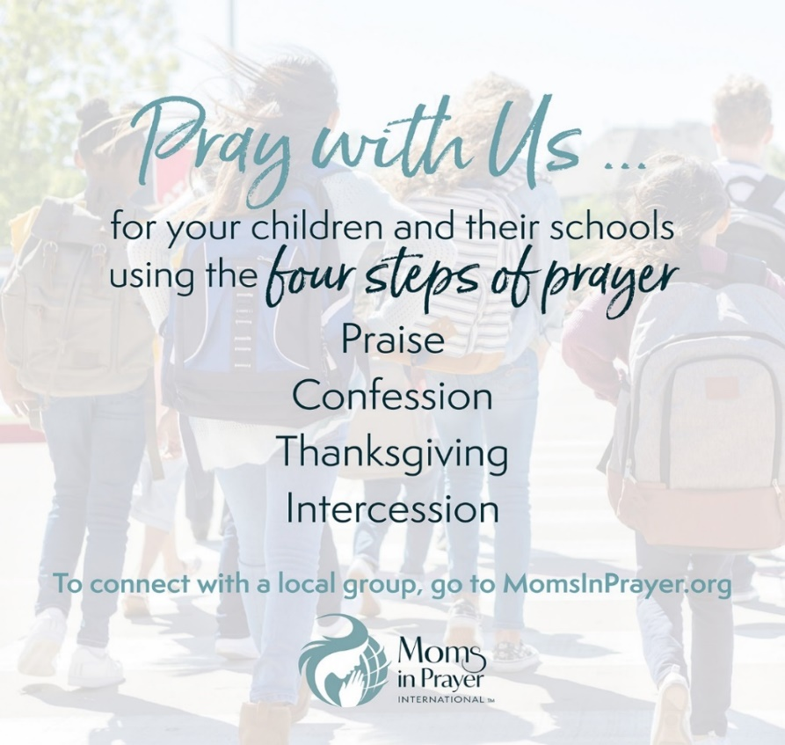
This resource is made available for individual use. No part of this study may be copied or distributed in conjunction with any another work or compilation. It may not be posted to any other website. All verses are NIV unless otherwise noted. For more information on Moms in Prayer International, visit MomsInPrayer.org.

This resource is made available for individual use. No part of this study may be copied or distributed in conjunction with any another work or compilation. It may not be posted to any other website. All verses are NIV unless otherwise noted. For more information on Moms in Prayer International, visit MomsInPrayer.org.

