
Praise—Praising God for who He is, His attributes, His name or His character
Attribute: God is Everlasting
Definition: One who is eternal; the same yesterday, today, and forever
Scripture(s): Psalm 90:2; Psalm 145:13; Isaiah 40:28
Confession—Silently confessing your sins to the God who forgives
If we confess our sins, He is faithful and righteous to forgive us our sins and to cleanse us from all unrighteousness. 1 John 1:9 (NASB)
Thanksgiving—Thanking God for what He has done
In everything give thanks; for this is God’s will for you in Christ Jesus. 1 Thessalonians 5:18 (NASB)
Intercession—Coming to God in prayer on behalf of others. Form groups of two to three.
Our Own Children—Each mom chooses one child. First pray the scripture then pray a specific request.
Scripture: God, may You search ________ and know his/her heart; test ________ and know his/her anxious thoughts. See if there is any offensive way in ________, and lead him/her in the way everlasting.
From Psalm 139:23-24
1st Mom’s Child specific request:

2nd Mom’s Child specific request:

3rd Mom’s Child specific request:
Teachers/Staff—Use the verse below or the verse for your child.
Scripture: Open __________’s eyes and turn him/her from darkness to light and from the power of Satan to God, so that he/she may receive forgiveness of sins and a place among those who are sanctified by faith in Jesus. From Acts 26:18
School Concerns
- Pray for revival and spiritual awakening at your school.
- Pray for protection over the staff and students at your school.
- Pray for other concerns at your school.
Moms in Prayer Concerns
- Pray that every school worldwide would be covered in prayer and that groups will be sustained.
- Pray for protection over the ministry, keeping it pure and unified.
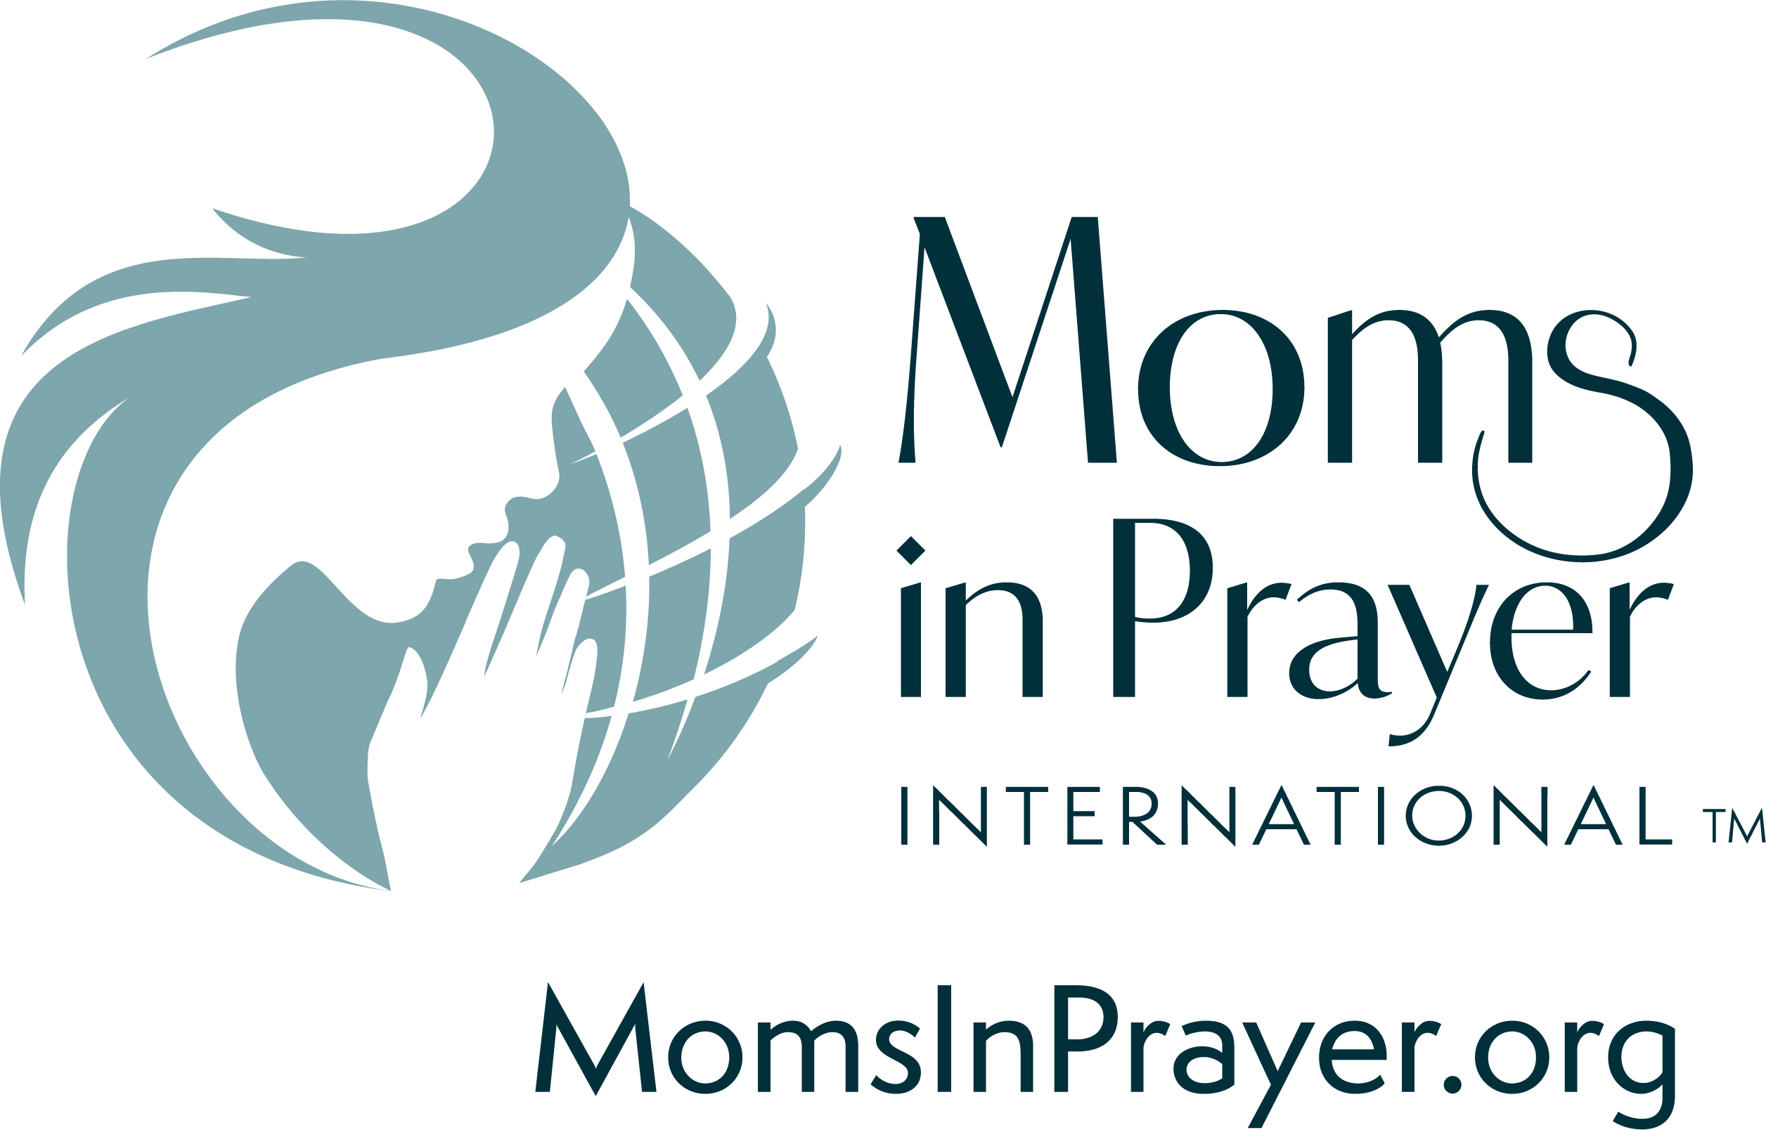
- Pray for more donors to partner with the ministry in equipping groups and reaching the nations.
Remember, what is prayed in the group, stays in the group!

