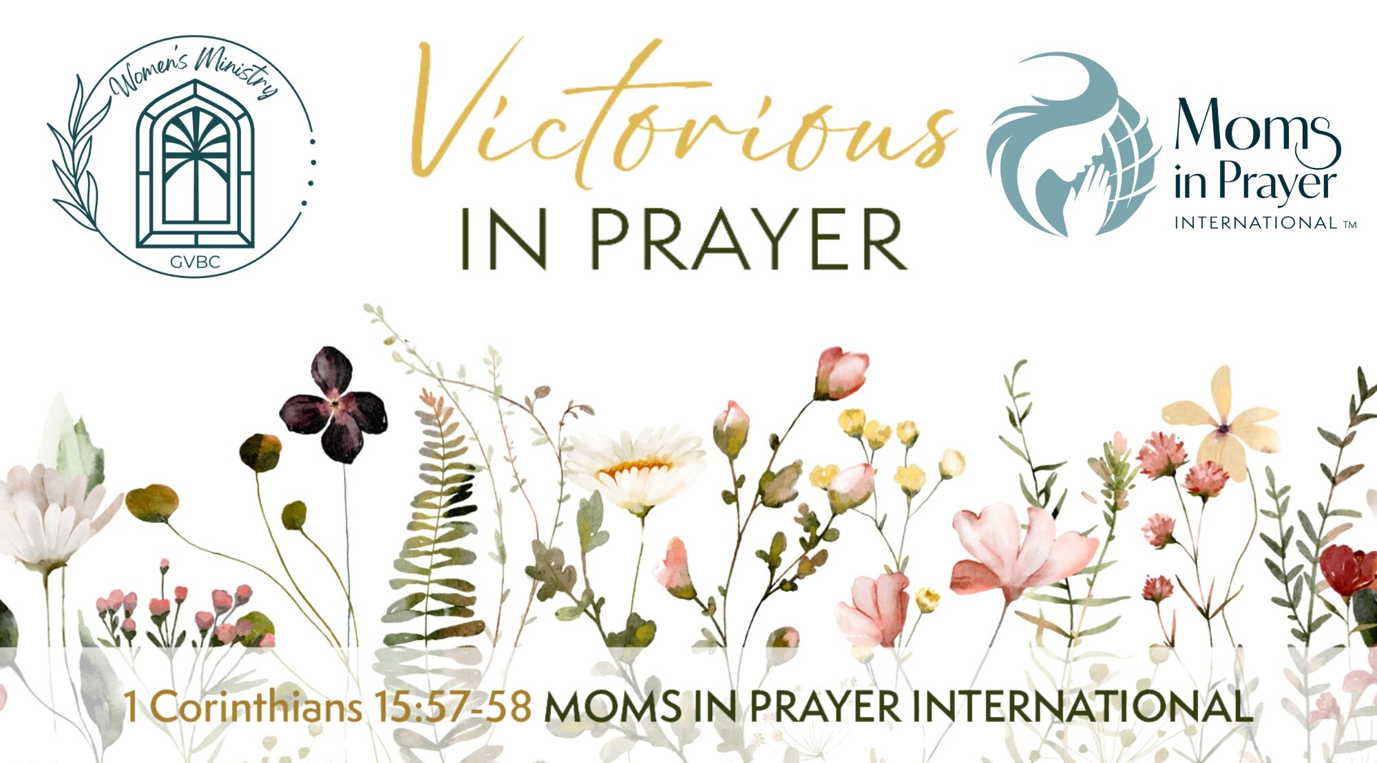

Victorious in Prayer Nevada
Friday, August 2, 2024
6:00pm – 8:30pm
Green Valley Baptist Church Fellowship Hall
270 North Valle Verde Drive
Henderson, NV 89074
Join us as we welcome our keynote speaker, Sally Burke,
president of Moms in Prayer International.
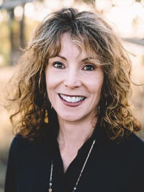
As we get ready to kick off a new school year, come hear testimonies of answered prayer and be a part of what the Lord is doing to cover kids and schools in prayer.
Light dinner will be provided.
Cost is $10.
Please bring a friend and join us on August 2!

Register at: https://momsinprayer.org/events/victorious-in-prayer-nevada/

For more info contact Samantha Clarke (702) 274-3341 or samantha0055@gmail.com

