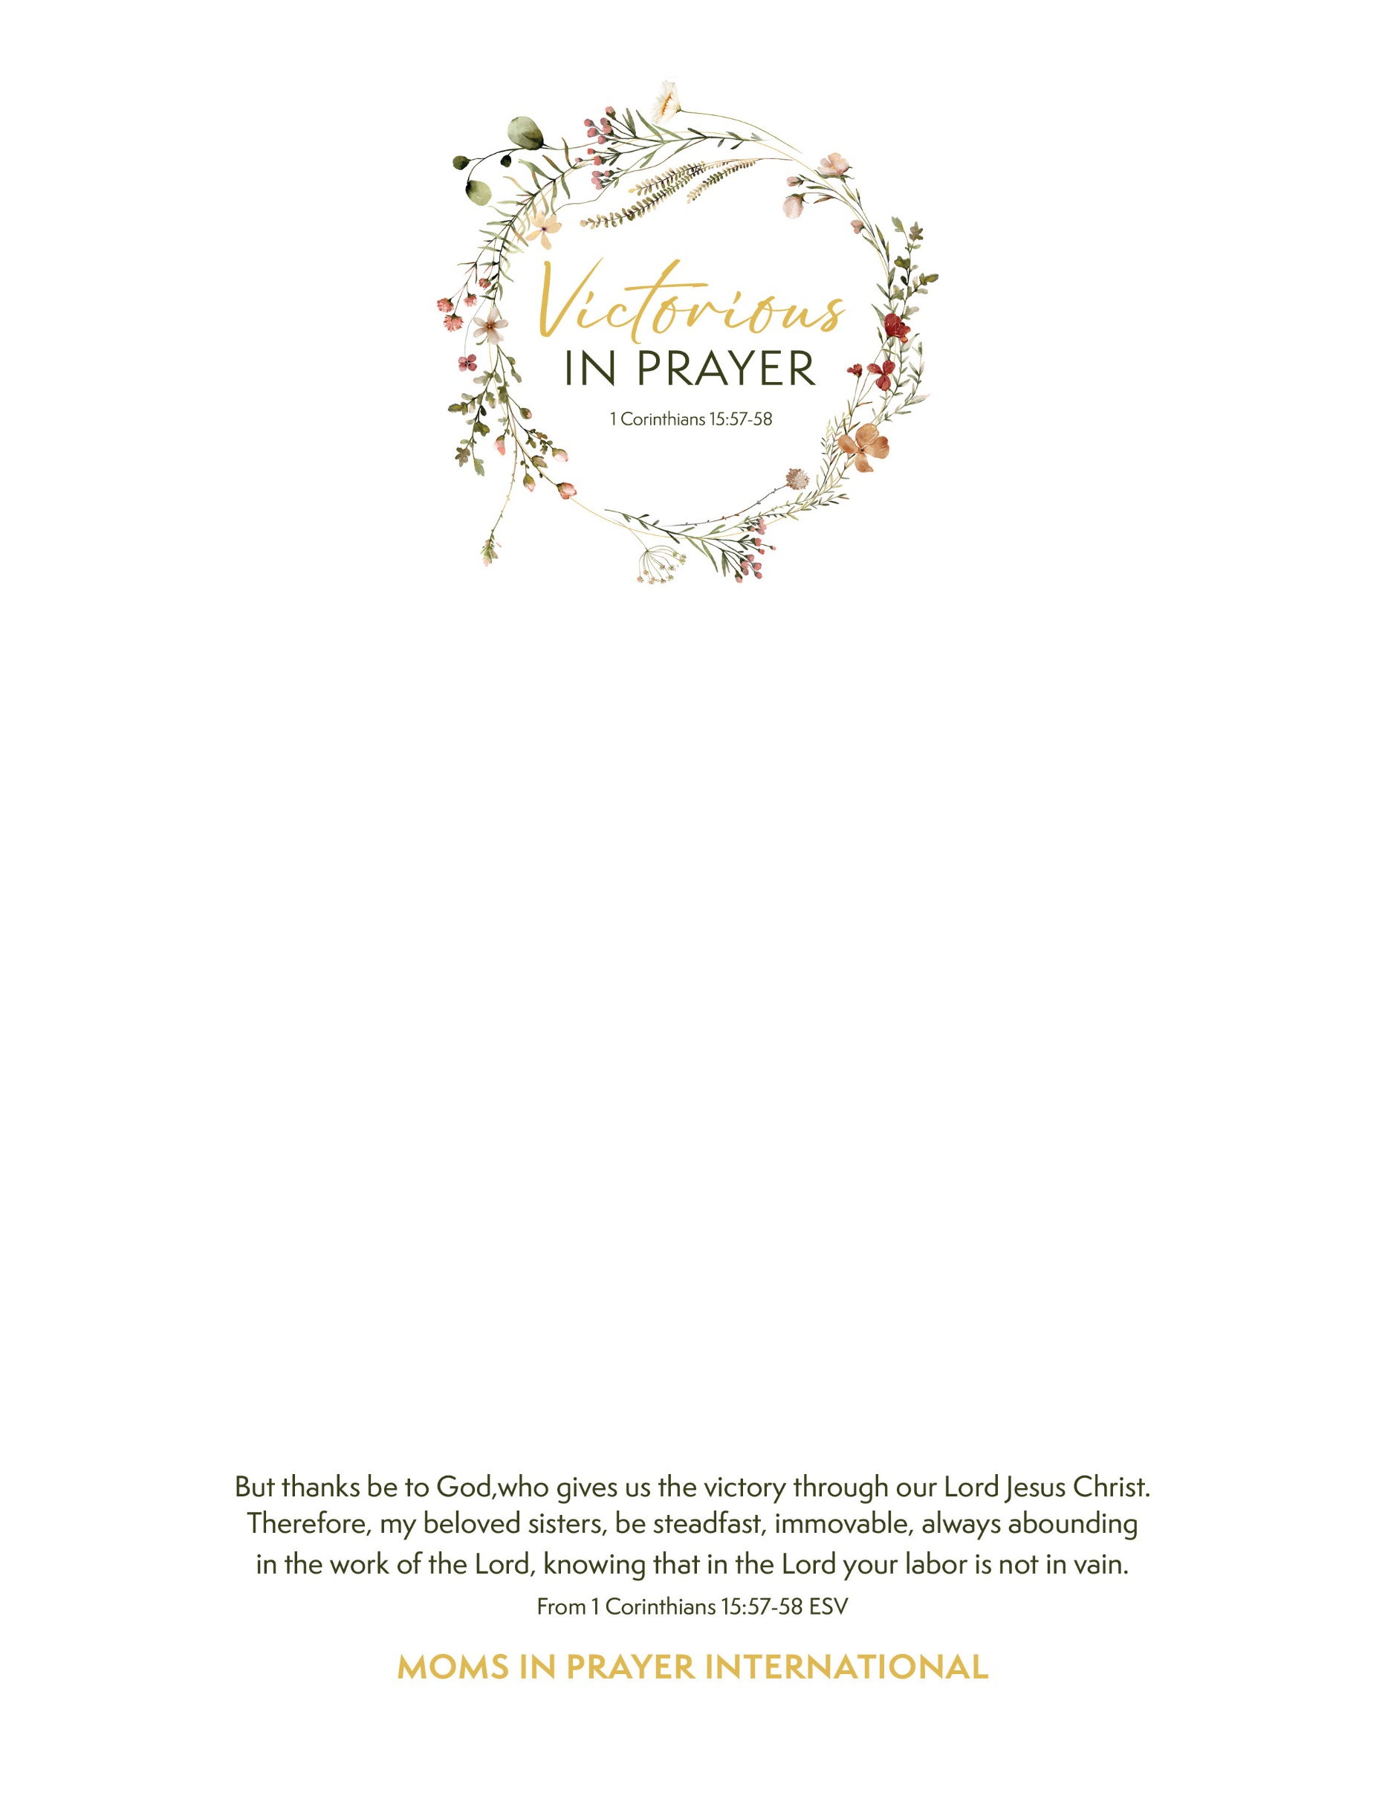

**Moms in Prayer and BG Kingdom Kids invite you to a pre-holiday inspiration breakfast for women who pray for, pray with, teach, love and care for children of all ages!**

**Victorious in Prayer – Tompkins and Tioga Counties**

**Saturday, November 16, 2024, 8:30am-10:30am**

Bethel Grove Bible Church Family Center

1763 Slaterville Road, Ithaca, NY 14850

**You are warmly welcome** to join us around the breakfast table for a restful time of worship and discussion, connecting with women who desire to have a profound impact on children and schools. You will be encouraged with song, the Word of God and sweet fellowship, and empowered as you discover the simple and effective Four Step method of prayer. This is a morning about hope, grace and practical joy that you won’t want to miss!

A free event. Invite a friend!

Healthy, refreshing breakfast fit for dedicated mama bears provided! No childcare available.

RSVP: Becky, [momsinprayer.beckytay@gmail.com](mailto:momsinprayer.beckytay@gmail.com), 607-319-1576