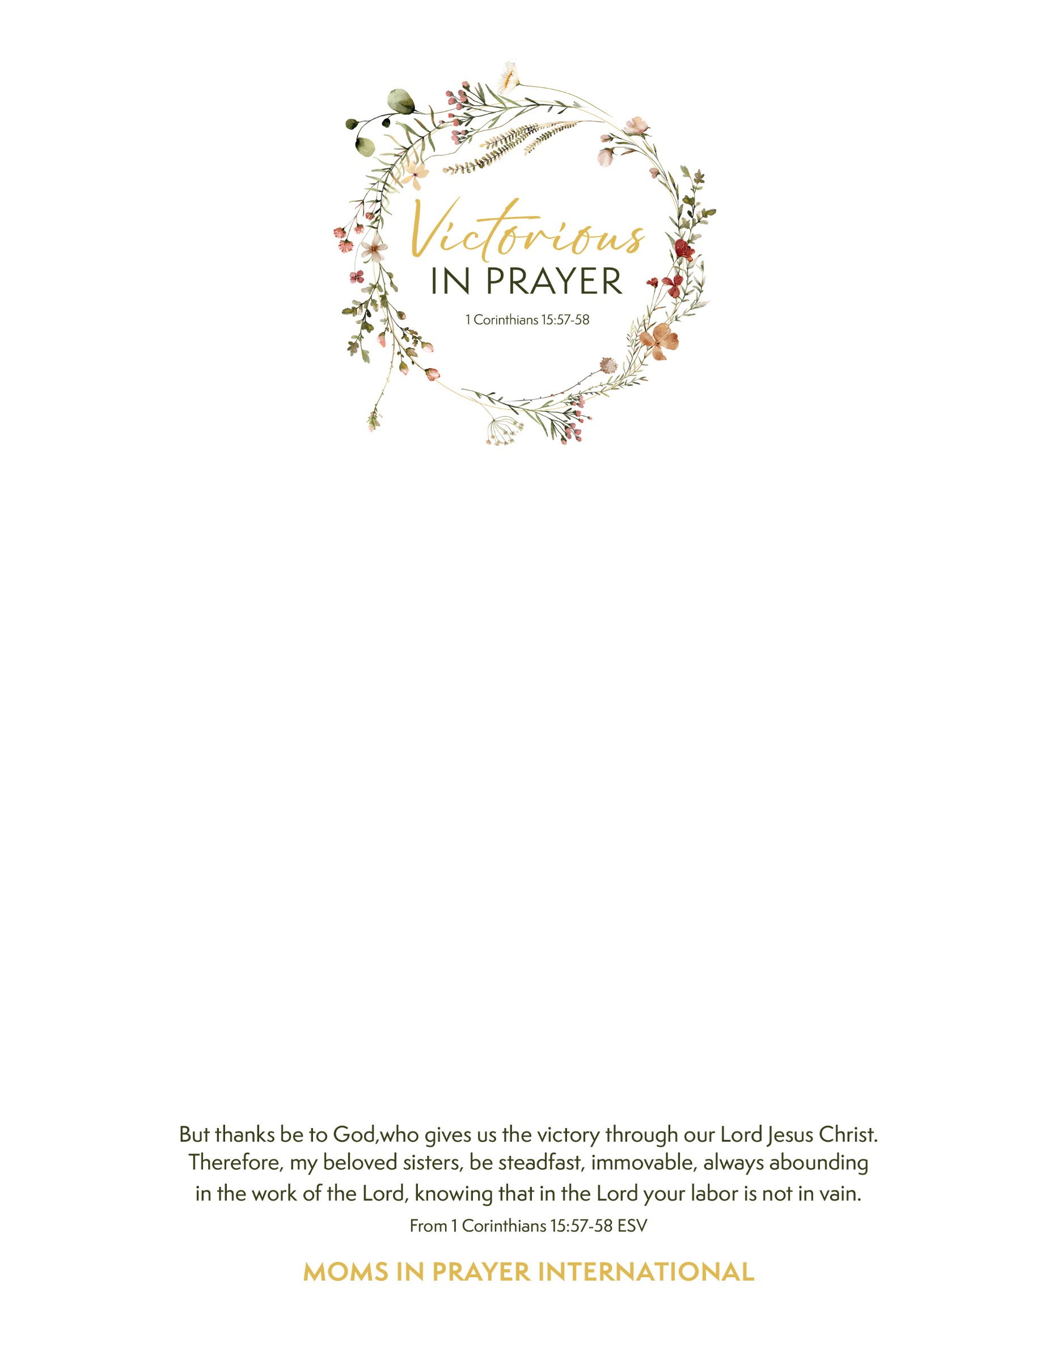

**Moms in Prayer invites you to have a profound impact on your children and their schools from preschoolers to adults.**

**Victorious in Prayer – Suffolk County**

**Saturday, November 9, 2024**

**Long Island Alliance Church**

**377 Deer Park Avenue, Dix Hills, NY 11746 10:00am to 12:30pm**

**You are invited** to learn about Moms in Prayer and spend time getting connected with women desiring to pray for their children and schools. You will be empowered as you discover the simple and effective Four Step method of prayer while being encouraged with hope and enjoying sweet fellowship with local women.

It’s a morning you won’t want to miss!

**Our Guest Speaker will be Jill Falletta**

A free event. Invite a friend!

**Light Refreshments. No childcare provided.**

**RSVP: Leslie labaars93@gmail.com (631) 707-6249**

Text ends here