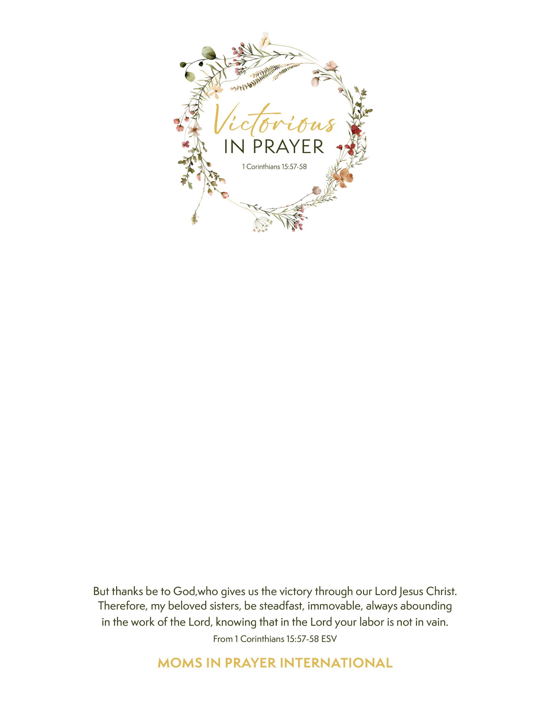

Join us for a half-day event where you’ll be refreshed in the joy, freedom, and victory you’ve been given through Christ. We will learn how to pray deeply and strategically for our children, grandchildren and their schools using the Word of God.

**Come and experience:**

* **Encouragement**: From MIP Appalachian Division Coordinator Heidi Fromke
* **Worship & Prayer:** Moments of worship that will bring you closer to God and new tools to help deepen your prayer life.
* **Community:** Connection with other women who share your values and passions.

This gathering is not just about learning; it’s about experiencing the love of God in

community. Come and see how praying with other moms can be pivotal to

cultivating a persevering, faith-filled prayer life.

**Saturday, January 25, 2025**

**9am-Noon**

**Silverdale Baptist Church - Main Campus Chapel**

**7236 Bonny Oaks Drive, Chattanooga, TN 37421**

Text ends here