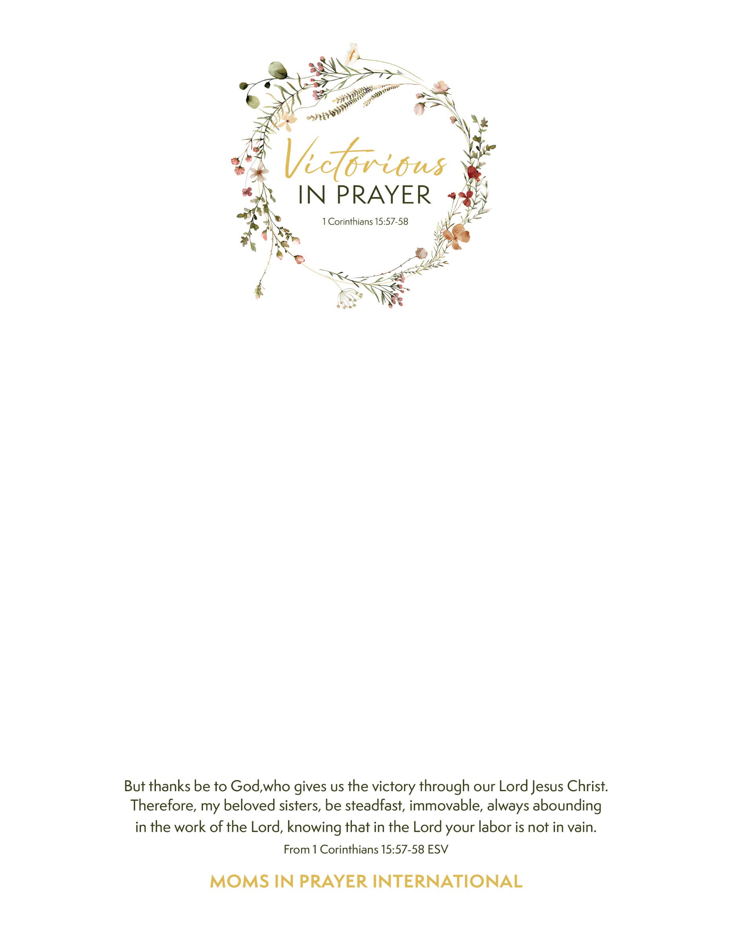

* You are invited to a special prayer event for mothers, grandmothers and aunts with children of any age **Friday, February 7 ~ 6:30-8:30pm** * Connect with other women from Hunt & Rains Co. and surrounding areas to worship, receive Biblical encouragement and pray for our children and schools. Replace your cares and worries with peace and hope as we pray scripturally and specifically using the four steps of prayer. **Ridin’ High Cowboy Church 8771 FM 35, Union Valley 75189** * Hosted by Moms in Prayer Int’l (MIPI) North Texas leadership ~ MIPI impacts children and schools worldwide for Christ by gathering mothers and grandmothers to pray. Register for FREE. Scan QR code or click [Moms in Prayer: Victorious in Prayer 2-7-25](https://www.signupgenius.com/go/8050D45ACAE2DA5F58-54287727-victorious#/) Or go to signupgenius.com and search by [jenny3118oil@yahoo.com](mailto:jenny3118oil@yahoo.com) Questions? Contact Jenny: 972-795-0371 or Tracey: 903-408-9670

