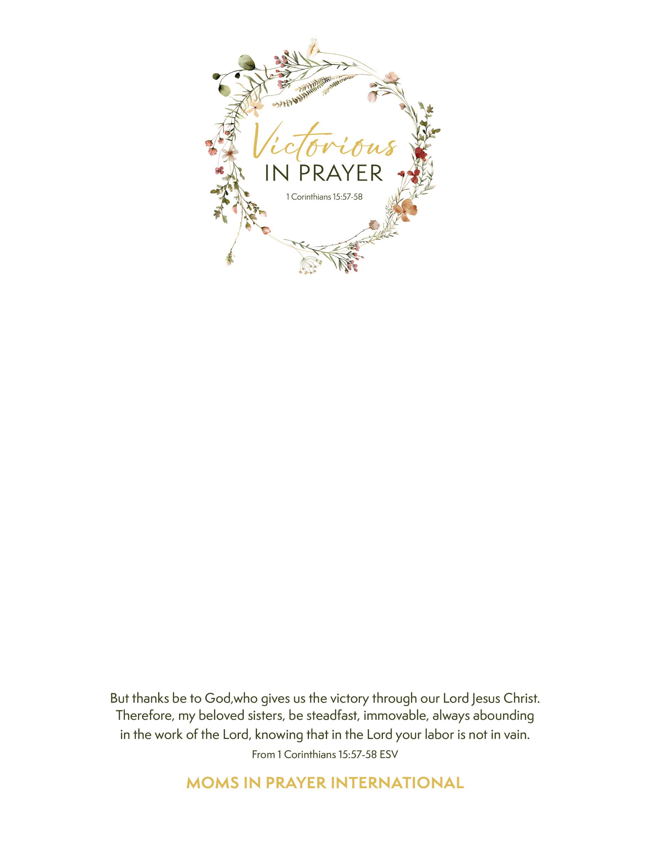

**MOMS IN PRAYER** invites you to be uplifted, encouraged and equipped in praying for your children and schools. Come meet and hear our president Sally Burke, as well as state, regional and area coordinators! Learn about our Four Steps of Prayer and be inspired by this global ministry. We invite moms, grandmas, or anyone who loves students. BRING A FRIEND who hasn’t heard of us!

**WHEN:** Thurs, Feb. 27, 2025 from 1-3 p.m.

**WHERE:** Foothills Bible Church 6100 S Devinney Way, Littleton, CO 80127 (second building on south end, past main building: 2nd floor “Loft”)

**NOTES:** no childcare; share this invite!

**RSVP:** by Feb. 25 (Walk-ins are welcome)

**QUESTIONS?** Diana Beck 303-523-9633

Text ends here